Autoignition of hydrogen/natural gas/nitrogen mixtures

Alice E. May*
Department of Mechanical Engineering and Metaphysics, University of the Yukon
-52 Lake Lebarge, YT, H0H 0H0, Canada
James Bond†
Turbulence and Energy Laboratory, University of Windsor
401 Sunset Ave, Windsor, ON, Canada

Abstract
This study investigates the influence of fuel jet composition on autoignition, ignition kernel propagation, and subsequent flame stabilization at conditions that are relevant for the practical operation of gas turbine reheat … (100~200 words).

Keywords: hydrogen; natural gas; combustion; autoignition; flame

Introduction
Please use this template and/or follow the format. Length of the paper should be 7-28 pages.

Font Size
Title: Times new roman (or equivalent) 16 points bold, centered.
Everything else: Times new roman (or equivalent) 12 points.

Methodology/Theory (or whatever sub-title your paper requires)

Results and Discussion (or whatever sub-title your paper requires)
All equations (mathematical and chemical) should be centred. If an equation is numbered, the number should be flush against the right margin. Use the Equation Style to simplify formatting:
$γ=\frac{{\overset{˙}{w}}_{k}}{ρ}+\frac{1}{T}\frac{ΔT}{Δt}$ (1)
${\text{CO}}_{2}+H_{2}⇔\text{CO}+H_{2}O$ (2)
Note that chemical symbols are not italicized whereas variables in the equations and in the text are written in italics.

Illustrations/Graphs
The illustrations/graphs/photographs and their captions should be included within the manuscript at a location closest to the first reference describing them. The labels, symbols and other information on the illustrations should be no smaller than 10 points. Illustrations/graphs/photos may be in color or black and white, but all non-illustration text (including captions) must be in black. Beware that the proceedings may be printed black and white and thus, make sure no information is lost when your colour figures are converted to “gray scale.”

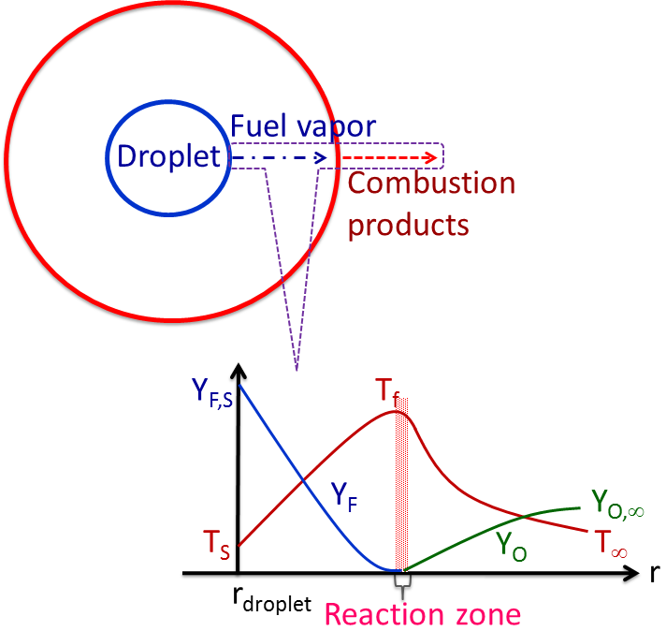
Figure 1. Droplet combustion under zero gravity and stagnant environment. T_{f} = temperature at the flame; T_{S} = temperature at the surface of the droplet; T∞ = ambient temperature; Y_{F,S} = fuel concentration at the surface; Y_{O} = concentration of the oxidizer; Y_{O,∞} = concentration of the oxidizer in the ambient.

Tables
Tables should be numbered consecutively. Footnotes to tables should be indicated by superior letters, beginning with “a”. Table caption precedes the Table, as shown below:

Table 1. Relative concentrations of species at 4000 K and 56 MPa.
Set | H | O | OH | CHª | N^{b} | S | R
1 | 0.01 | 0.03 | 0.08 | 0.01 | 0.08 | 0.03 | 0.01
2 | 0.08 | 0.01 | 0.03 | 0.08 | 0.03 | 0.01 | 0.03
3 | 0.03 | 0.03 | 0.01 | 0.03 | 0.01 | 0.08 | 0.01
4 | 0.01 | 0.08 | 0.03 | 0.01 | 0.03 | 0.01 | 0.08
5 | 0.08 | 0.03 | 0.08 | 0.03 | 0.01 | 0.03 | 0.01
ª Estimated by using reaction 324.
^{b} Obtained from RKM approximation.

Conclusions/Concluding Remarks

Units:
Please use the SI system of units.

Acknowledgements

Any acknowledgement you might wish to include goes here.

References

References should be indicated in the text by full-size numbers in brackets, e.g., [1], and should be numbered in the order cited.

Journal Papers:
- A. R. Vasel-Be-Hagh, R. Carriveau, D. S-K. Ting, “A balloon bursting underwater,” Journal of Fluid Mechanics, 769: 522-540, 2015.
- P. F. Henshaw, T. D’Andrea, K. R. C. Mann, D. S-K. Ting, “Premixed ammonia-methane-air combustion,” Combustion Science and Technology, 177: 2151-2170, 2005.

Thesis:
- M.R. Student, Stuff that took me a year too long, MASc. thesis, Institute for Engineering Studies, University of Canada, Iqualuit, NU, Canada, 2010.

Book:
- D. S-K. Ting, Thermofluids: From Nature to Engineering, Academic Press, New York, 2022.

Paper or Chapter in an Edited book:
- H. Burns, I.M. Hot, in: U.R. Pyro (Ed.), Large Scale Fire Dynamics, Taylor and Francis, London, 1988, p.502.

Conference Proceedings:
- M.T. Head, I.M. Done, Another Novel Nano-bio-energy Thing, Proceedings of Combustion Institute Canadian Section Spring Technical Meeting, May 15-17, 2012, pp.3.1-3.6.

